CS511: PSP + [Personal] Project
Personal SpreadSheet Process - Level 0

A. Winsor Brown
AWBrown@CSE.USC.edu

Course Goals

After completing this PPMP part of the course, you will:

Have practiced and know how the P[SE]PMP provides a basis for the Project Management quality and productivity improvements the students invariably experience

See how PPMP is a basis for on-going improvements and for PSP

Have practiced and built personal tools for

Earned Value Planning and Tracking

Linear Regression and Prediction Intervals

Mulitple regression

Have learned and be ready to practice PSSP

Presentation Outline

Explain PPMP0s' tasks, activities, processes and artifacts

PSSP0s' tasks, activities, processes and artifacts

First Exercise: Simple size data calculations

Watts' Process Elements

Software & Project Management Process Elements

Defined scripts for performing the tasks

A set of

forms

templates

instructions
for

planning

tracking

recording

An improvement procedure, with process improvement proposal (PIP) forms and facilities

PSSP0 & PSP0 Process Flow (Framework)
WH Book page __
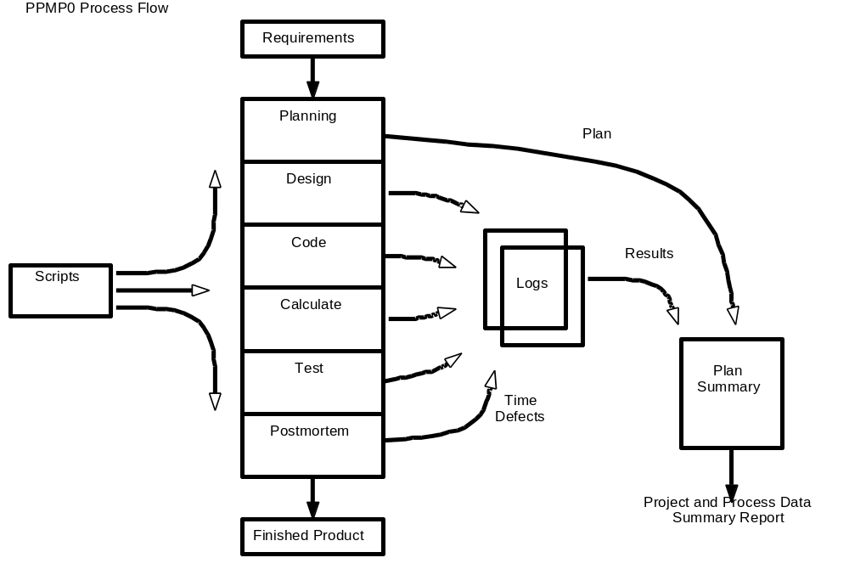

PSSP0 & PSP0 Project Plan Summary
Student | Wilman Rincon | Date | 1/27
Program | Mean standard deviation | Program # | 1
Instructor | Luis Daniel | Language | Java

Time in Phase (min.) | Plan |  | Actual |  | To Date |  | To Date %
Planning |  |  | 7 |  | 7
Design |  |  | 20 |  | 20
Code |  |  | 40 |  | 40
Calculate/Compile |  |  | 0 |  | 0
Test |  |  | 8 |  | 8
Postmortem |  |  | 10 |  | 10
Total | 120 |  | 85 |  | 85

PPMP0 & PSP0 Project Plan Summary (cont.)
Defects Injected |  | Actual |  | To Date |  | To Date %
Planning
Design
Code
Calculate/Compile
Test
Total Development
Defects Removed |  | Actual |  | To Date |  | To Date %
Planning
Design
Code
Calculate/Compile
Test
Total Development
After Development

PPMP & PSP Process Time Recording Log
Student |  | Date
Instructor |  | Spreadsheet #

Date | Start | Stop | Interruption  Time | Delta  Time | Phase | Comments

PPMP & PSP Defect Recording Log
Defect Types: | 30 Build, Package | 60 Checking | 90 System
10 Documentation | 40 Assignment | 70 Data | 100 Environment
20 Syntax | 50 Interface | 80 Function

Student |  | Date
Instructor |  | Spreadsheet #

Date |  | Number |  |  |  | Type |  | Inject |  |  |  |  | Remove |  |  |  | Fix Time |  |  |  | Fix Defect
Description:
Date |  | Number |  |  |  | Type |  | Inject |  |  |  | Remove |  |  |  | Fix Time |  |  |  | Fix Defect
Description:

The "Personal Software Process" PPMP & PSP
PSSP0s' & PSP0s' Process Decomposition
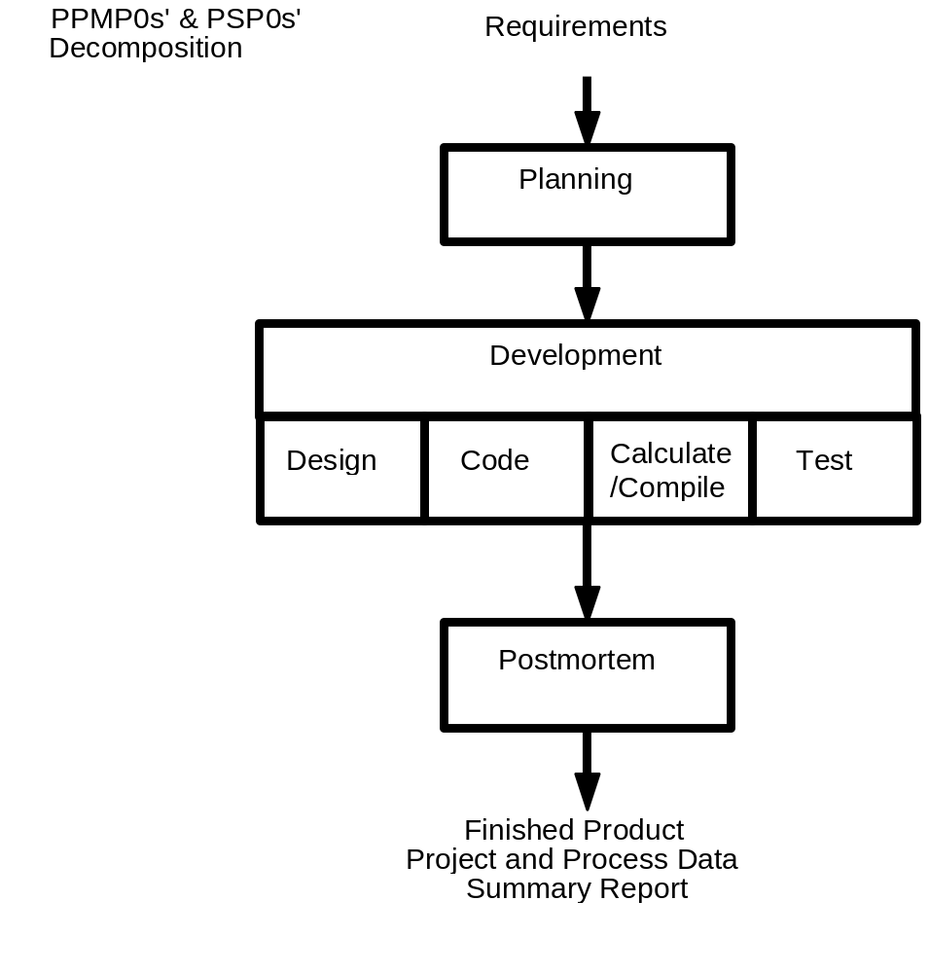

PSSP0 Process Script
Φ | Purpose | To Guide you in developing module-level spreadsheets
 | Inputs Required | - Problem description  - PPMP0 Project Plan Summary form  - Time and Defect Recording Logs  - Defect Type Standard  - Stop watch (optional)
1. | Planning | - Produce or obtain a requirements statement.  - Estimate the required development time.  - Enter the plan data [estimate] in the Project Plan Summary form.  - Complete the Time Recording Log.
2. | Develop-ment | - Design the spreadsheet.  - Code (implement) the design.  - Calculate the spreadsheet and fix and log all defects found.  - Test the spreadsheet and fix and log all defects found.  - Complete the Time Recording Log.
3. | Post-mortem | Complete the Project Plan Summary form with actual time, defect, and size data
 | Exit Criteria  Condition | - A thoroughly tested spreadsheet  - Completed Project Plan Summary with estimated & actual data  - Completed Defect and Time Recordings Logs

PSSP0 Planning Process Script
Φ | Purpose | To guide the PSSP & PSP planning process
 | Entry Condition | - Problem description  • PSSP0 (or PSP0) Project Plan Summary form  - Time Recording Log
1. | Spread-sheet Rqts | - Produce or obtain a requirements statement for the spreadsheet  - Ensure the requirements statement is clear and unambiguous.  - Resolve any questions.
2. | Estimate Resources | - Make your best estimate of the time required to develop this spreadsheet.
 | Exit Condition | - [A d] Documented requirements statement  - [A complete] Project Plan Summary with estimated development time data  - Completed Time Recording Log

PSSP0 Development Process Script
Φ | Purpose | To guide the development of small spreadsheets
 | Entry condition | - Requirements statement • Time and Defect Recording Logs  - Project Plan Summary with estimated [planned][development time  - Defect Type Standard
1. | Design | - Review the requirements and produce a design to meet them.  - Record in the DRL any requirements found.  - Record time in Time Recording Log.
2. | Code | - Implement the design: automatic calculation off & formula mode.  - Record in the DRL any requirements or design defects found.  - Record time in Time Recording Log.
3. | Calculate | - Formula mode off  - Calculate the spreadsheet until error free.  - Fix all defects found. • Record defects in Defect Recording Log.  - Record time in Time Recording Log.
4. | Test | - Test until all tests run without error. • Fix all defects found.  - Record defects in Defect Recording Log.  - Record time in Time Recording Log.
 | Exit condition | - Thoroughly tested spreadsheet  - Completed Defect Recording Log  - Completed Time Recording Log

PPMP0 Postmortem Process Script
Φ | Purpose | To guide the PPMP & PSP postmortem process
 | Entry Condition | - Problem description and requirements statement  - Project Plan Summary with planned development time  - Completed Defect Recording Log • Completed Time Recording Log  - A tested and running spreadsheet.
1. | Defects Injected | - Determine from the DRL the number of defects injected in each phase.  - Enter this number under Defects Injected—Actual on the PPS.
2. | Defects Removed | - Determine from the Defect Recording Log the number of defects removed in each PPMP0 (or PSP0) phase.  - Enter this number under Defects Removed—Actual on the Project Plan Summary.
3. | Time | - Review the completed Time Recording Log.  - Enter the total time spent in each PPMP & PSP0 phase under Actual on the Project Plan Summary form.
 | Exit Condition | - A fully tested spreadsheet  - Completed Project Plan Summary form  - Completed Defect and Time Recording Logs

Next Session

First Exercise — Spreadsheet #1
Standard Deviation & Linear Regression
bVery Last Line- format is Tiny

